Every Friday Members draw, you must be in the club to win the money |  | Every Friday Members draw,
Sept  Saturday 20 – Juno Rising  Sunday 21 – Bingo 8pm  Wednesday 24 – Bingo 8pm  Saturday 27 – Sunstroke  Sunday 28 – Quiz 3pm, Bingo 8pm  Oct  Wednesday 1 Bingo 8pm  Saturday 4 – The 45’s  Sunday 5 - Bingo 8pm  Wednesday 8 – Quiz 8pm  Saturday 11 – Made for Radio  Sunday 12 – Quiz 3pm, Bingo 8pm  Wednesday 15 – Bingo 8pm  Friday 17 – Club’s birthday, Horse racing 7.30 – MEMBERS ONLY  Saturday 18 – Damian Lodrick  band 8.30  Sunday 19 – Bingo 8pm  Wednesday 22 – Bingo 8pm  Saturday 25 – Limited S  Sunday 26 – Quiz 3pm, Bingo 8pm  Wednesday 29 - Bingo 8pm  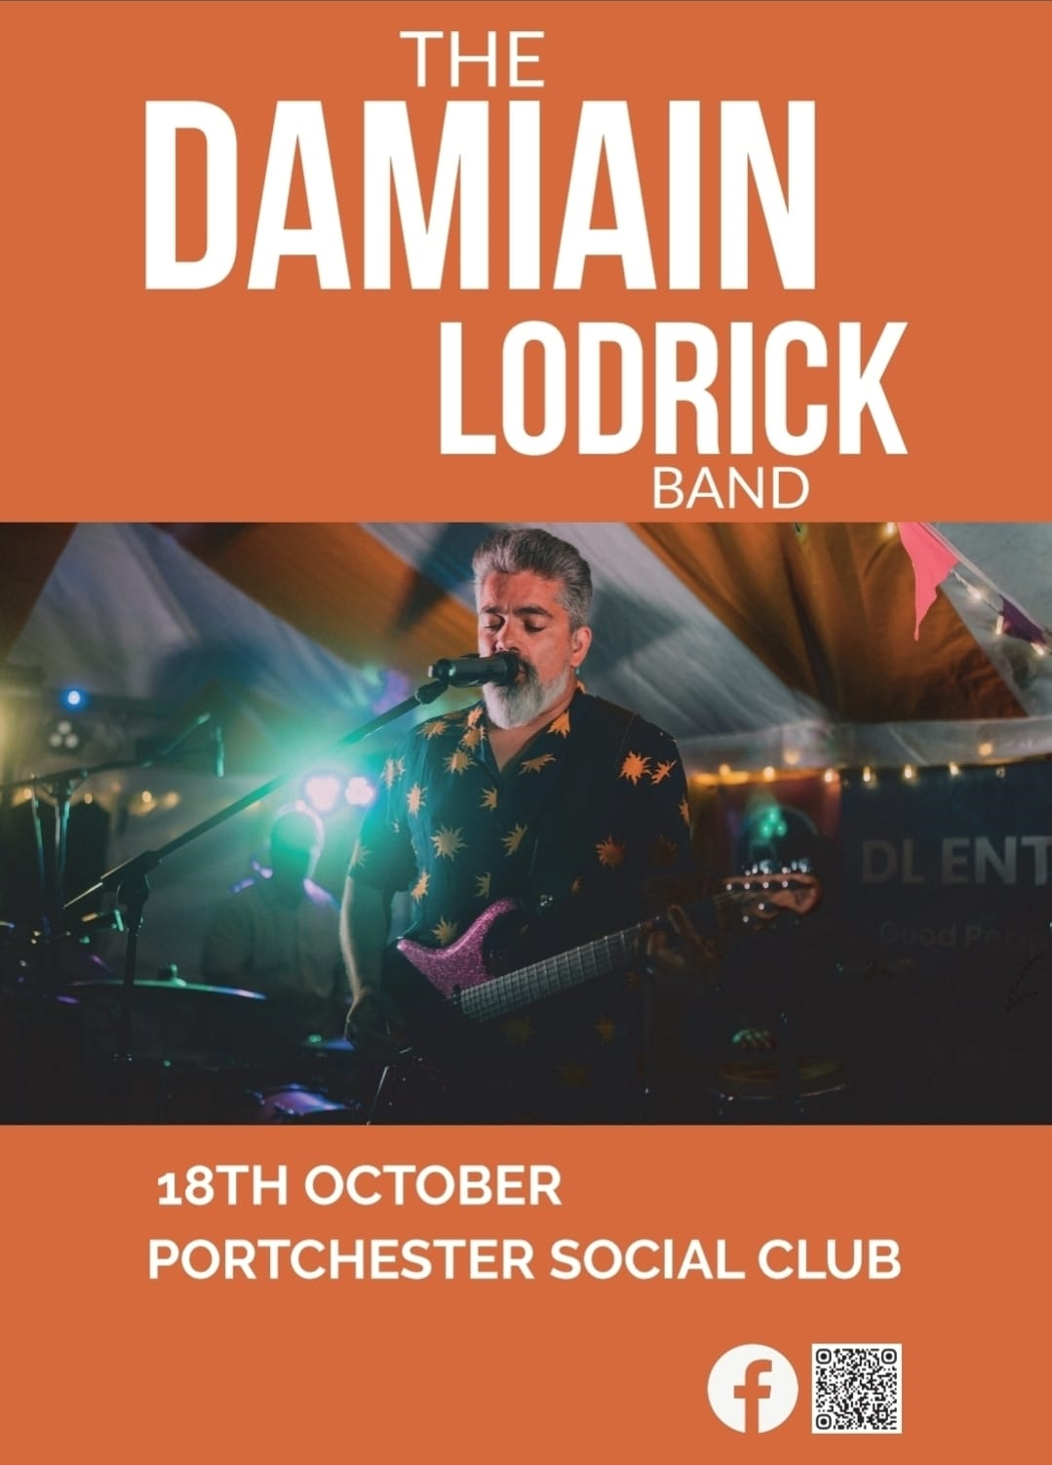 | Nov  Saturday 1 – The Ace Tones  Sunday 2 – Bingo 8pm  Wednesday 5 – Bingo 8pm  Saturday 8 – Dynamo Disco  Sunday 9 – Quiz 3pm, Bingo 8pm  Wednesdays 12 – Quiz 8pm  Friday 14 – Friday Night Live -  Maya Dodkins 8-10pm  Saturday 15 - Voltaires  Sunday 16 – Bingo 8pm  Wednesday 19 - Bingo 8pm  Saturday 22 – Jasper’s  Sunday 23 – Quiz 3pm, Bingo 8pm  Wednesday 26 - Bingo 8pm  Saturday 29 – The Boppers  Sunday 30 – Bingo 8pm  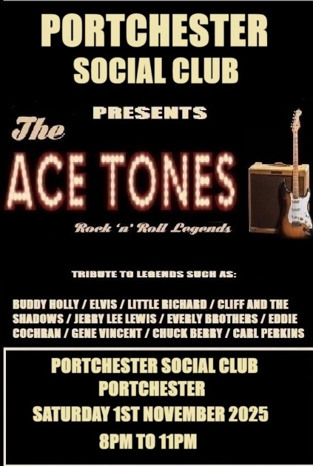 | Dec  Wednesday 3 - Bingo 8pm  Saturday 6 – Pop Pickers  Sunday 7 - Quiz 3pm, Bingo 8pm  Wednesday 10 – Quiz 8pm  Saturday 13 – Creative Covers  Sunday 14 – Kid’s Xmas Party  3pm – 5pm, Santa 5pm - 6pm,  Bingo 8pm  Wednesday 17 – Bingo 8pm  Friday 19 – Christmas Draw – MEMBERS ONLY 7.30pm  Saturday 20 – The Beat Collective  Sunday 21 – Quiz 3pm, Bingo 8pm    Wednesday 24 Xmas Eve  Dynamo Disco  Saturday 27 – Stevie P    New Years Eve  Retro Beats 8.15 pm   | Join our Facebook page for weekly updates    or go to our website  https://portchestersc.wixsite.com/website    Or WhatsApp  Please do not take this copy.  Other menus are available to takeaway

